I Have A problem

BRIGHT IDEAS El-CIVICS PROJECT

STUDENT GUIDE

VIDEO Transcript

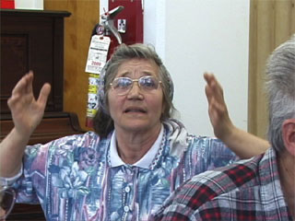

This document is a transcript of the video: “I Have a Problem, Scenarios and Situations for Just-in-Time Civics.” The transcript allows students to follow along with the video to improve comprehension. The students in the video were enrolled in an English Literacy – Civics course sponsored by the Coalition of Limited English Speaking Elderly (CLESE). They were asked to use English to discuss a variety of common problems.

I Have A problem

Scenarios and Situations for Just-in-Time Civics

OPENING CREDITS AND INTRODUCTION

I Have a Problem
Scenarios and Situations for
Just-in-Time Civics

One of the
Coming to America Series
The Immigrant Elderly in Chicago

Produced by the
Coalition of Limited English Speaking Elderly

In association with Aguirre International

With funding from the
U.S. Department of Education
Illinois Department of Human Services
Retirement Research Foundation

As part of the Bright Ideas Project:
Innovations in EL-Civics

Bright Ideas is a project that brings together elderly
immigrants and refugees from many countries.
The students in this video are taking one of the
Bright Ideas English and civics classes.

They are from the Ukraine, Bosnia, Romania and the Philippines.
The teacher is from China.

Students discuss real life situations and learn to use English
as they solve problems.

Taiqin, the teacher, gives students some common problems to discuss.
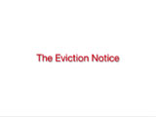 | The Eviction Notice
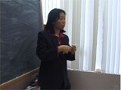 | You received an eviction notice telling you you have to move out of your apartment. And the reason, as is stated, is that you failed to pay the rent. You didn’t pay your rent. Which is not true. What will you do, and what will you say? Elvira?
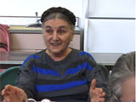 | Yah, I say, not true. I pay. I pay every month. I paid. Yes, I paid every month. No true no pay this month. Because, first problem every month is pay my bills. Rent bill, telephone, electricity and gas.
Teacher | How can you prove you paid? How can you prove? Luba?
 | You give receipt. (Teacher) The receipt? (Student) You show the receipt. (Teacher) You show the receipt.
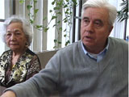 | I will show him the copy of the check. Here is the number.
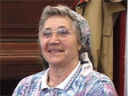 | No receipt, no pay, no check. I have to move.
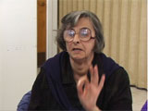 | I will call my manager. I say, sorry, I don’t pay my rent. I don’t have money. But I pay now. Immediately.
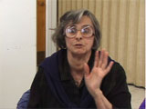 | Please. Sorry. I don’t forgot. I not here. I live in apartment 10 days. I go visit in my country. But I come back yesterday. I pay now, immediately. Sorry. It’s my mistake. But I think you help me. Don’t move me.
 | In winter, they cannot remove you. Only in summer.
Teacher | Is that a rule?
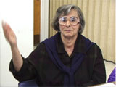 | Please, can you cancel my move. Because it’s now it’s very cold, it’s windy. I move in summer. Maybe June.

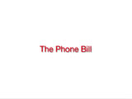 | The Phone Bill
Teacher | Your phone bill is very, very high.
Teacher | The phone company says you called your country ten times in one week.
Teacher | It is not true. What will you do? What will you say?
 | I will call, hello my name Yakof Lashock, my phone number is xxx-xxx-xxxx. I have received your bill for this month. I assume here is a big mistake. It’s a bill about $1000. I cannot call so much.
 | I call only to Ukraine, Israel, Russia. I have never called to Brazil, Mexico, Australia, because I don’t have any relatives and friends in this countries. Please check and please cancel this bill because it is wrong.
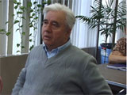 | I would call to the phone company and tell them that I got the bill and I have to pay a lot of calls, which I didn’t do. And I would tell them all the dates about the calls, the wrong calls and time, and ask please make investigation and call me back.

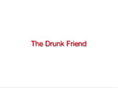 | The Drunk Friend
Teacher | You go to a party with an American friend. Your friend drives.
Teacher | When it is time to leave, you see that he or she is drunk, and you can’t drive yourself.
Teacher | What will you do? What will you say?
 | I will - maybe taxi. (Teacher) Take a taxi? Good. (Student) Maybe bus.
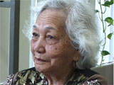 | I will get another driver, another car… Another way, I would just take bus.

 | The Lost Wallet
Teacher | You left your wallet on the counter in a store.
Teacher | It contains your Green Card and $50 in it.
Teacher | What will you do and what will you say?
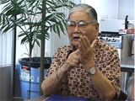 | I will call on the telephone because every receipt of the grocery there is a number of that telephone. And when they answer me - hello, good morning, I am Deo. I go to the store this morning. But, sorry, I left my wallet, maybe at the counter where I paid my grocery.
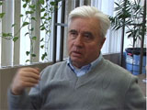 | I would say, excuse me please, 5 minute ago I was here and I left my wallet with a green card and $50 on the counter. Can you help me please? When I have another document, I will show that I am the owner of the wallet.

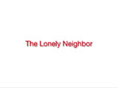 | The Lonely Neighbor
Teacher | She’s from another country - speaks a little bit of English. (She seems sad.) And she’s your neighbor.
Teacher | What will you do? What will you say?
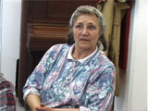 | In this situation, I will call my friend, I call her, don’t worry, don’t worry. We too don’t speak English very well. Don’t worry.
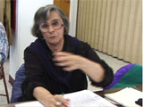 | I made coffee, special coffee, Bosnian coffee. If you have time you come in my home and talking about your problems why you are looking sad, very sad. And I think I will be helpful for her.
 | I could tell her, not be so frustrated, not be so alone. Please, we can go together to the park, outside. Please come to our English class.
 | We have wonderful teacher, good students. We will study together English. We will communicate and you will be not alone. And you will be in program English. You will be happy. You will be not so depressed and nervous.

 | A Real Life Problem
 | We asked students to talk about problems they have had and to give advice to others.
 | Here is one story.
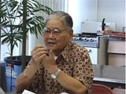 | I received a letter from the Public Aid that they will discontinue my Food Stamps and my Medicare. They find the records that I have a house in the city of Manila that I gave to my daughter. And they asked me if they paid to me or not.
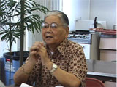 | I answered them, in the tradition of the Filipino custom, if a father or mother has a property and give to the son or daughter, there is no payment.
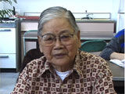 | I am sorry for that matter because I am very sick man. I have many medicines, and afterwards they will not now pay my medicine. They stopped up my Public Aid.
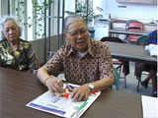 | 10 kinds of medicine every day. 5 in the morning and 4 in the afternoon, PM.
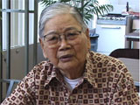 | Where shall I get the pay? I have no work. I have no job. I’m too old. I’m 85 years old… Please pray for me.
Teacher | What can we do to help him? What advise do we have. What do you recommend? What he should do? So, we can share something with Deo. What should he do?
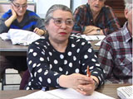 | I think he must go to lawyer.
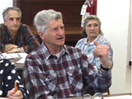 | I think the first time maybe he has to apply to a caseworker. He’s old ... At the same time he has to go to the maybe Philippine-American Association across the street.
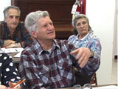 | And maybe they have an independent free lawyer and they could help him because they know Filipino customs because father or mother don’t receive money from their children for property.
 | We could put paper here and write, “Please help me, I have heart problem.” I go to the City Hall. Demonstration… Springfield… Please help me. I have heart problem.
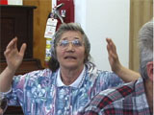 | Last hope so is in God. God help me. I have heart problem. I pray, in church, I sing. Da da da, da da da…
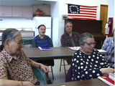 | …spontaneous singing of Amazing Grace…
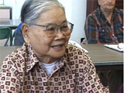 | Thank you my good teacher, and to my beloved classmates for the advise to me. And now I learned very much. And now I love you and you love me. God bless us. Thank you very much.
Produced by
Coalition of Limited English Speaking Elderly
Production Team
Heide Spruck Wrigley, James Powrie, Rosemary Gemperle, Taiqin Dong, Aliza Becker
 | Many thanks to the students, teachers and agencies that participate in the CLESE Bright Ideas Project.
Music
Aunque El Mono Se Vista De Seda, Mono Se Queda
Written by David Long 2000
Performed by Coal Train

